International Journal of pharma and bio sciences

ELSEVIER indexing

Official Letter received from ELSEVIER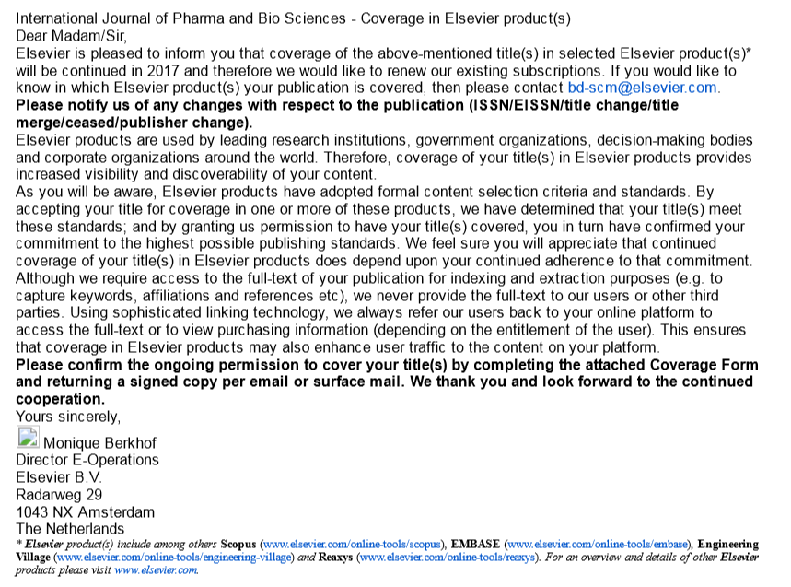

SCOPUS Indexing (2010-2016)

Indexed in SCOPUS (ELSEVIER) (for other details of indexing kindly refer or visit respective webpages)
- Source : https://journalmetrics.scopus.com/
Weblink accesssed on 14 jan 2017 - https://journalmetrics.scopus.com/
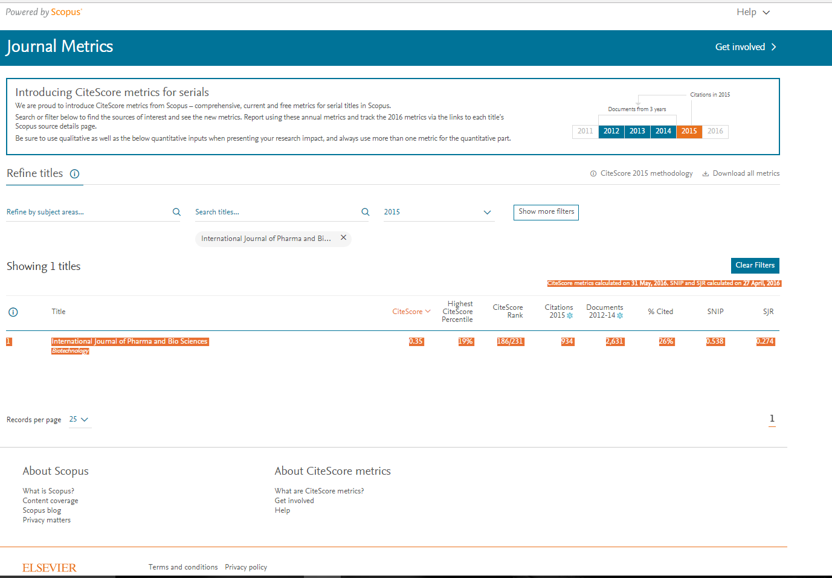
- Source : https://www.scopus.com/sourceid/20600195619
Weblink accesssed on 14 jan 2017 - https://www.scopus.com/sourceid/20600195619

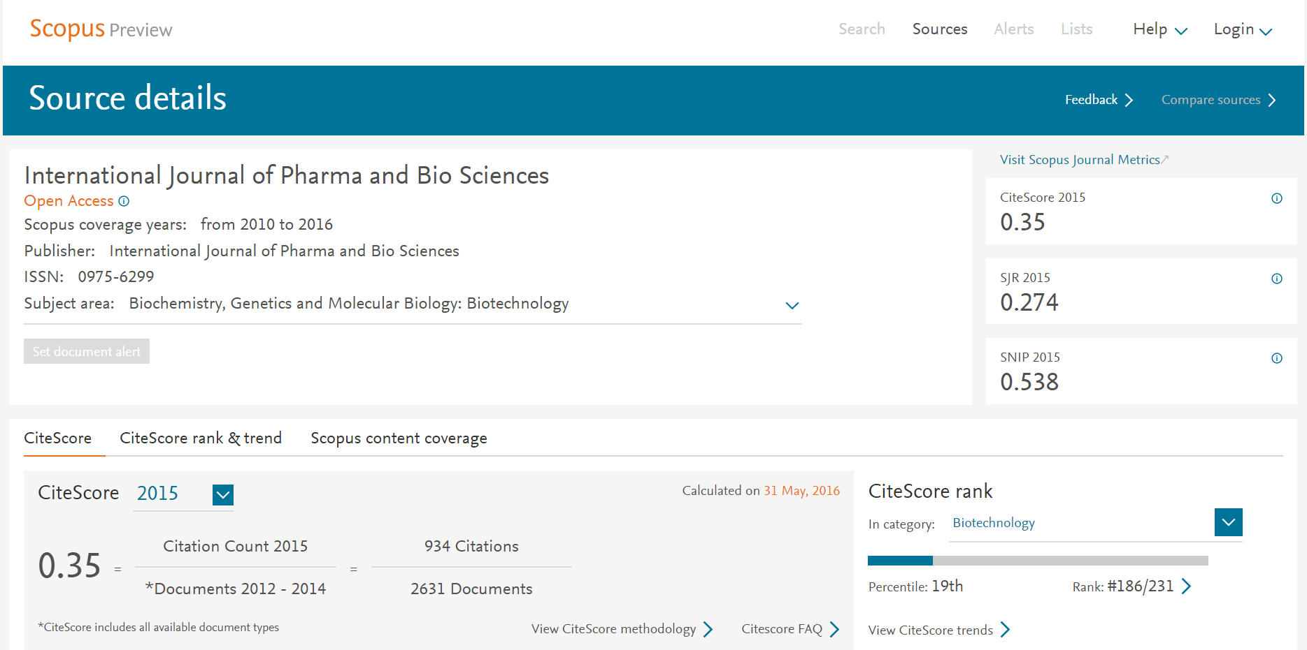
Embase (Elservier)-till date indexed
https://www.elsevier.com/solutions/embase-biomedical-research
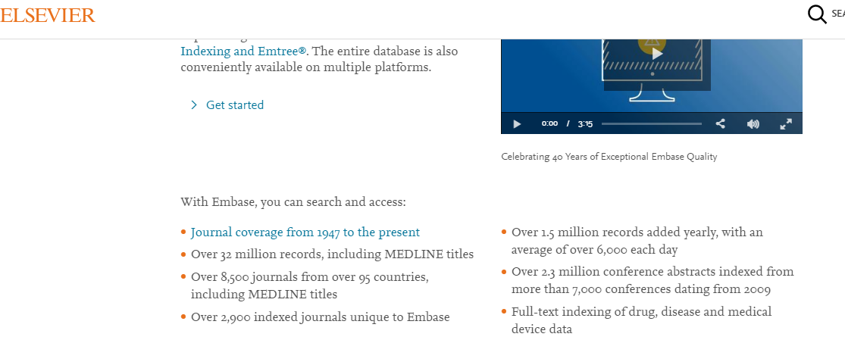
Click here
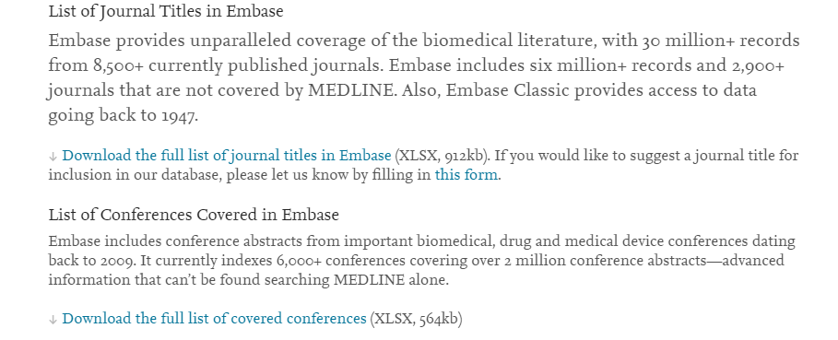
Click here
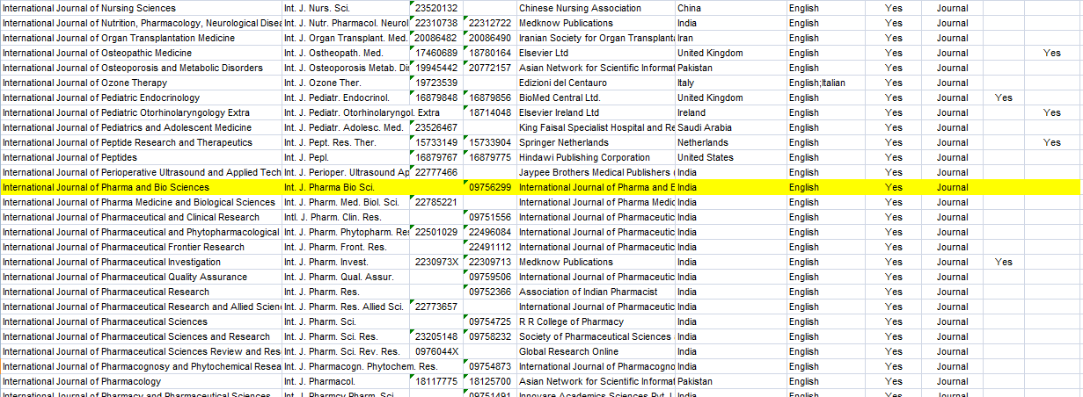

Scientific Journal Impact Factor (SJIF) indexing

Source: Weblink accesssed on 14 jan 2017 - http://sjifactor.com/passport.php?id=1867
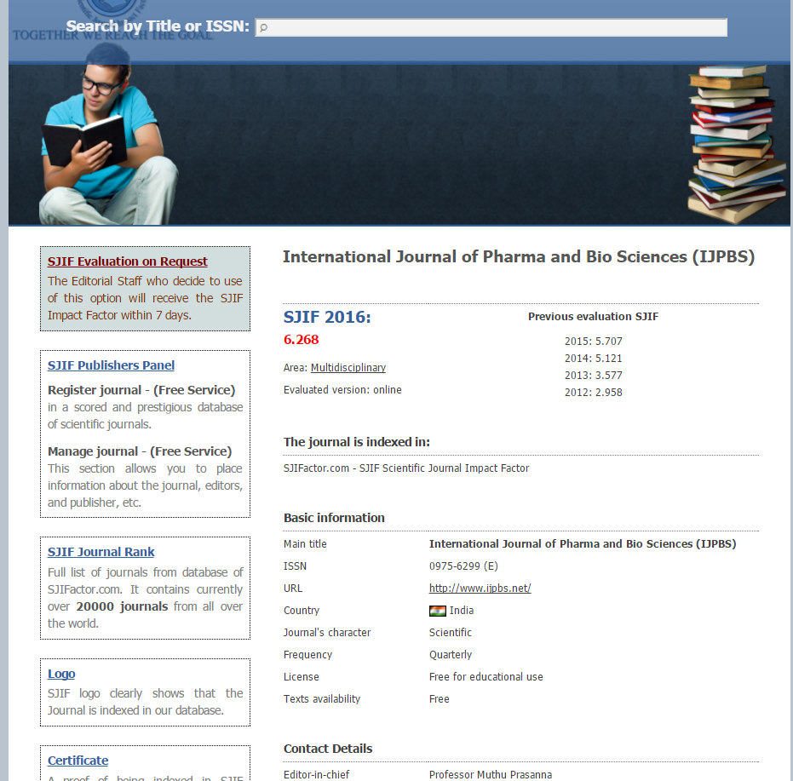

Index coppernicus
ICV index coppernicus
ICV was calculated by index coppernicus and found to be 116.39 for 2015. Refer http://journals.indexcopernicus.com/ for details.
#Accesssed on 14 jan 2017 http://journals.indexcopernicus.com/International+Journal+of+Pharma+and+Bio+Sciences,p396,3.html
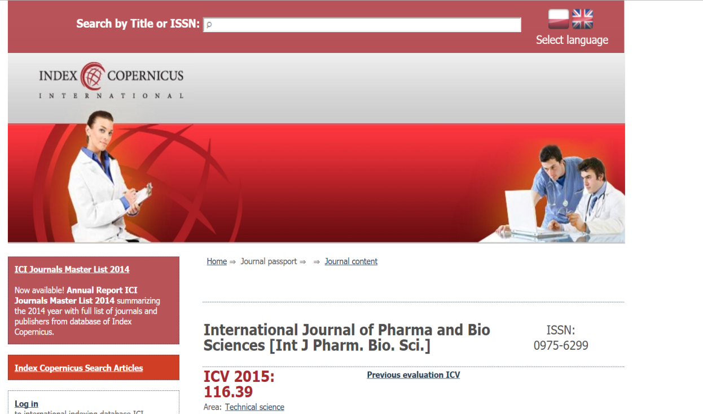
DOI Indexing
#Accesssed on 14 jan 2017 http://search.crossref.org/http://search.crossref.org/
DOI of ijpbs is https://doi.org/10.22376/ijpbs
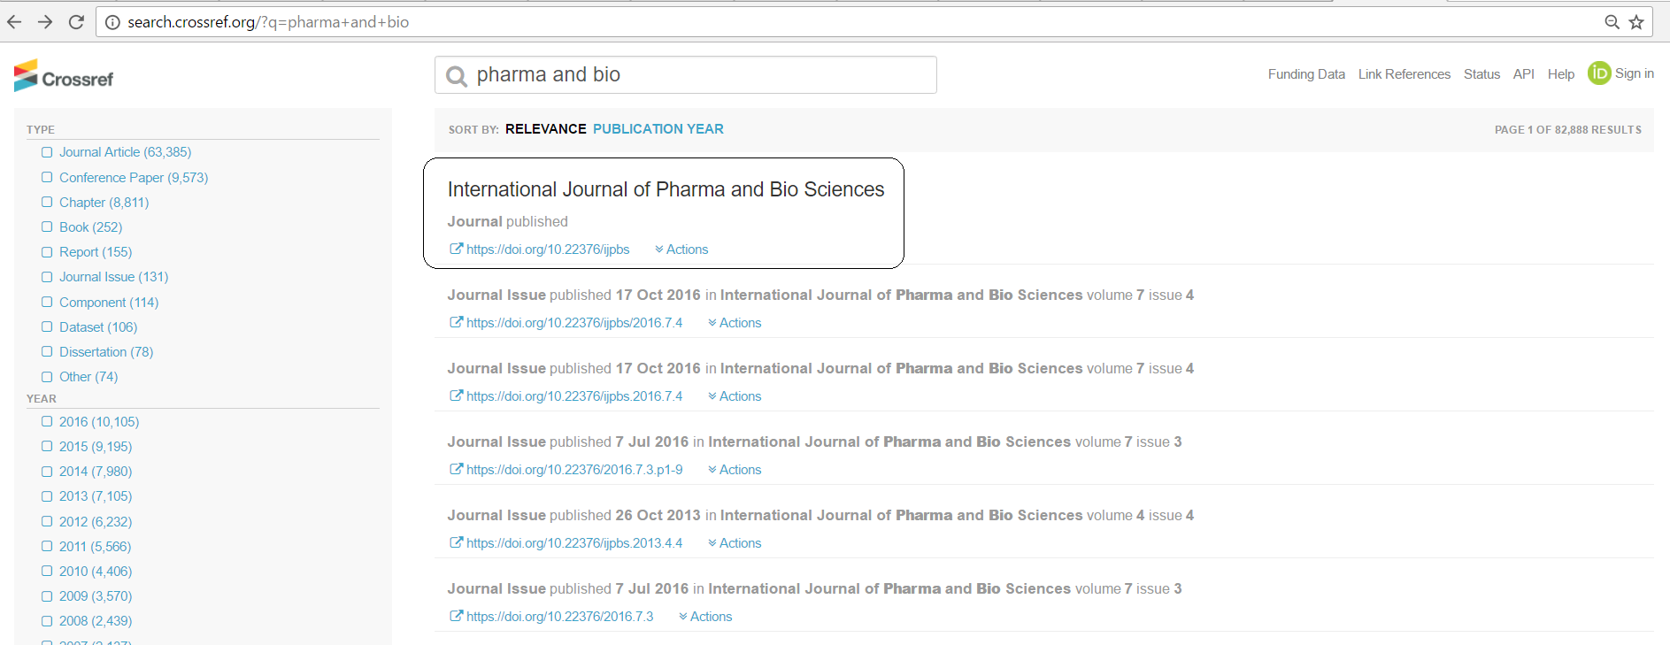
Above Indexings are subjected to change at any time by the respective indexing bodies which may or may not be updated in this listings. Viewers/readers/authors/others may refer the respective official webpages for any updation.

